A Review Of Liver Patient Analysis Methods Using Machine Learning

## INTRODUCTION

**1.2. Overview**

Liver diseases averts the normal function of the liver. This disease is caused by an assortment elements that harm the liver. Here we understand and analyze the problem of liver patient and solving the problem. This disease diagnosis very costly and complicated. The goal of this work is to evaluate the performance of different Machine Learning algorithm is used to reduce the high cost of liver disease diagnosis. And early prediction of liver disease within a short duration of time. Here we will analyze the parameters of various classification algorithms and compare their predictive accuracies so as to find out the best classifier for determining the liver disease.

## 1.2. Purpose

The purpose of this project to reduce some of the delays caused by unnecessary detours between the hospital and the pathology laboratory.

# Problem Definition & Design Thinking

## Emapthy map

. 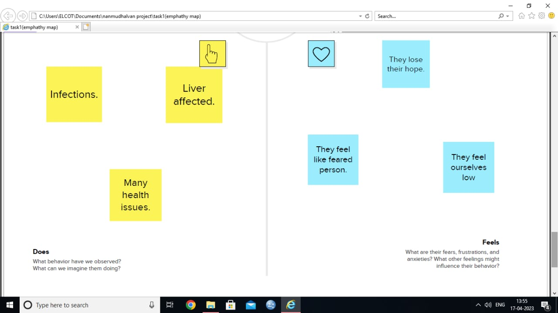 , ,. . ,. . , ,

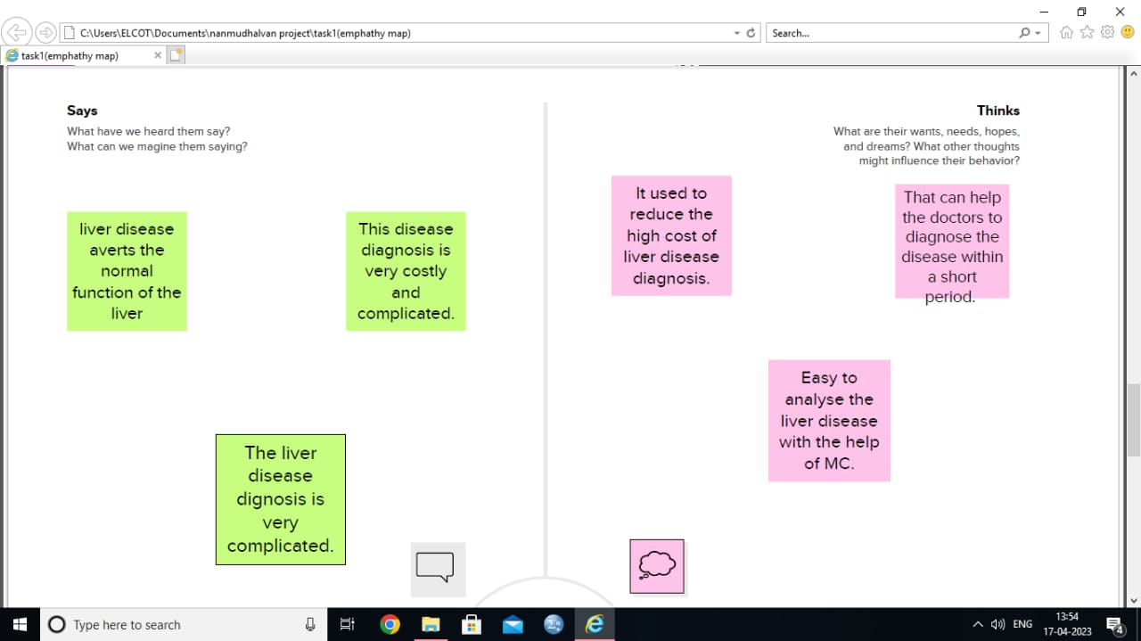

* 1. **Ideation and Brainstorming Map**

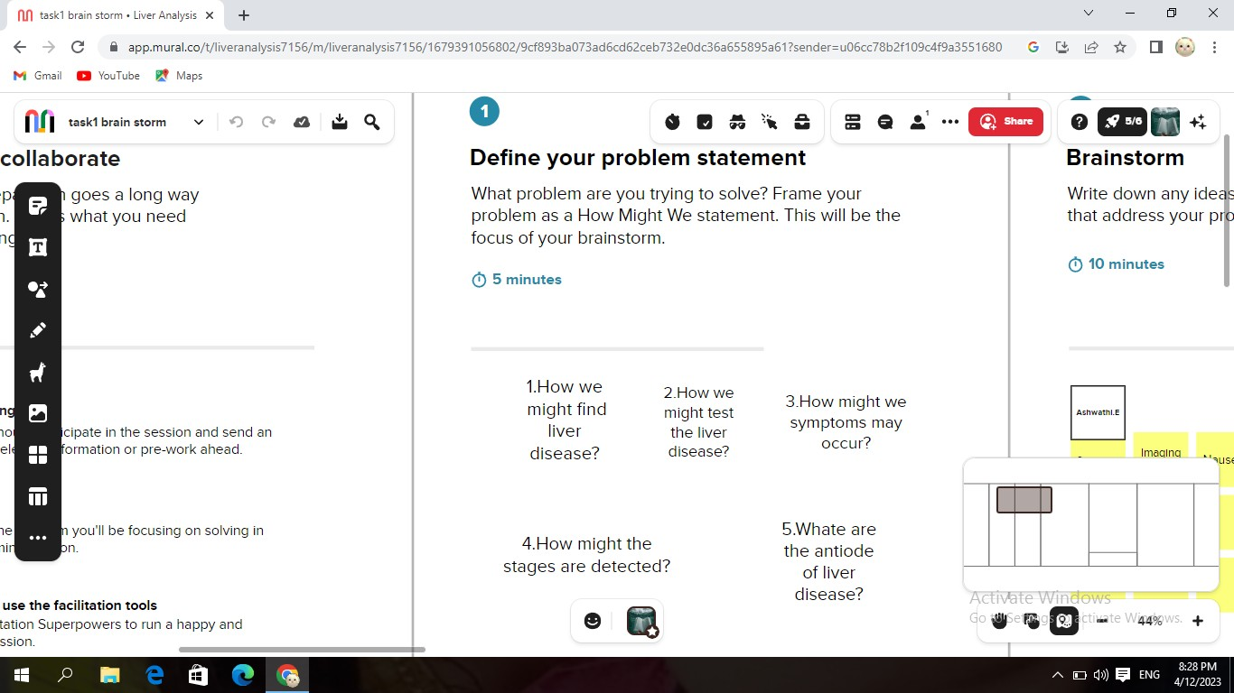

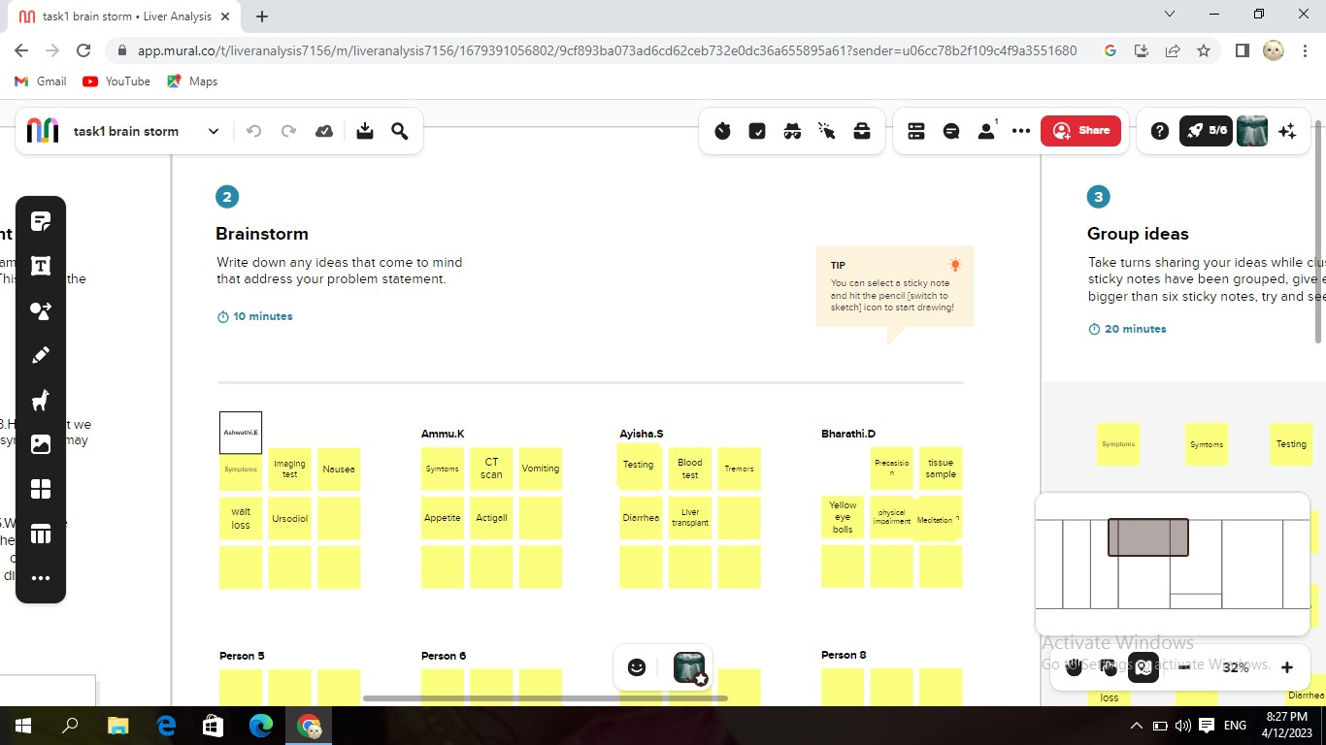

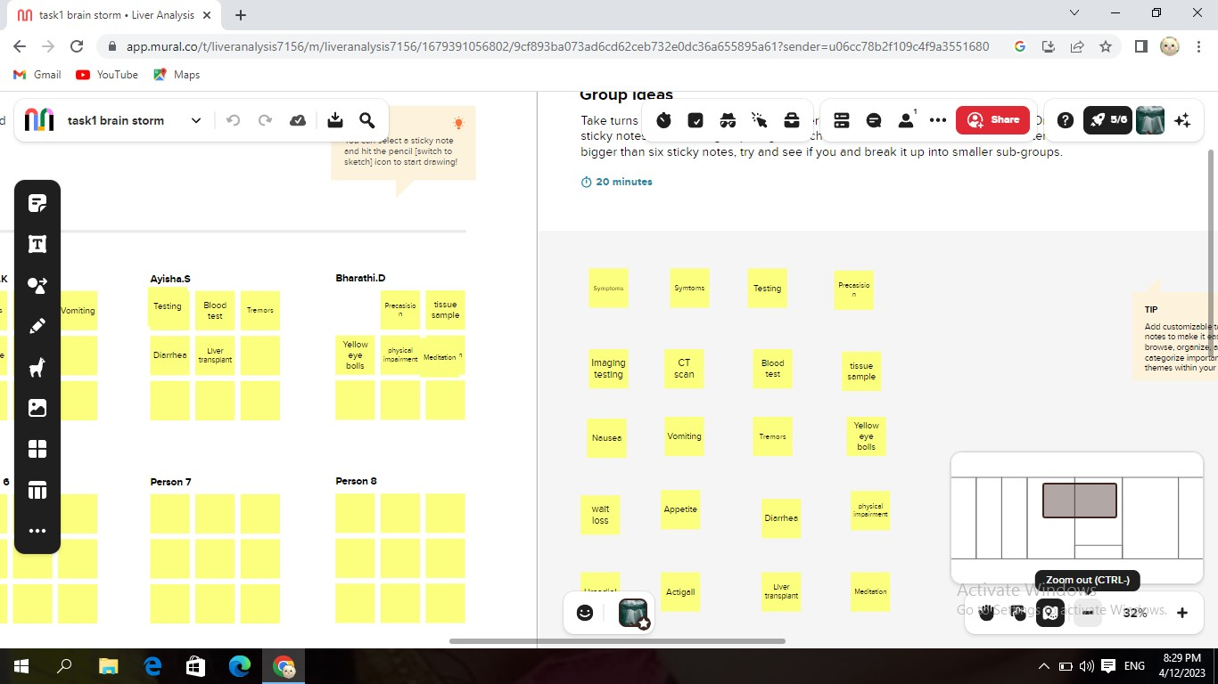

# Advantages and Disadvantages

## Advantages

* + - Evaluates abnormal liver function tests.
    - Identifies hepatotoxicity.
    - Clarifies uncertain diagnoses.
    - Liver transplant- Identifies acute cellular rejection.
    - Diagnoses other liver processes.

## Disadvantages

* Accessibility to the procedure
* Need for training
* Repeated testing
* Cost
* Sampling error

# Applications

* In Liver transplant
* Diagnosis other liver proecesses
* Used to avoid Repeated testing and etc…

# Conclusion

This study shows a data-based methods that can be used to access aspects of liver related data. Provides an intelligend and effective aspect of liver disorders prediction program are used.

# Future Scope

In this studies have been proposed to classify liver cancer mainly into primary-and secondary cancer. Primarily, data limitation has been observed for development of reliable CAD. The aim is to show the user end to check the level of prediction of liver disease on the behalf of their real time deagnosis report.

# APPENDIX

## Source Code with output

**Home.html**

|  |
| --- |
| <!DOCTYPE html> |
|  | <html lang="en"> |
|  | <head> |
|  | <title>Bootstrap Example</title> |
|  | <meta charset="utf-8"> |
|  | <meta name="viewport" content="width=device-width, initial-scale=1"> |
|  | <link rel="stylesheet" href="https://maxcdn.bootstrapcdn.com/bootstrap/3.4.1/css/bootstrap.min.css"> |
|  |  |
|  | <style type="text/css"> |
|  | body{ |
|  | background-color: #ffcf0059; |
|  | } |
|  | nav{ |
|  | background-color: #ad38c2; |
|  | height: 60px; |
|  | } |
|  | .navbar-brand{ |
|  | color: white; |
|  | font-size: 30px |
|  | } |
|  |  |
|  | nav ul li a{ |
|  | color: white; |
|  | font-size: 20px |
|  | } |
|  | </style> |
|  | </head> |
|  | <body> |
|  |  |
|  | <nav class="navbar"> |
|  | <div class="container-fluid"> |
|  | <div class="navbar-header"> |
|  | <a class="navbar-brand">Liver Patient Analysis</a> |
|  | </div> |
|  | <ul class="nav navbar-nav navbar-right"> |
|  | <li><a href="#">Home</a></li> |
|  | <li><a href="/predict">Goto Predict</a></li> |
|  | </ul> |
|  | </div> |
|  | </nav> |
|  |  |
|  | <div class="container"> |
|  | <h3>Introduction</h3> |
|  | <p>Liver diseases averts the normal function of the liver. Mainly due to the large amount of alcohol consumption liver disease arises. Early prediction of liver disease using classification algorithms is an efficacious task that can help the doctors to diagnose the disease within a short duration of time. Discovering the existence of liver disease at an early stage is a complex task for the doctors. The main objective of this paper is to analyse the parameters of various classification algorithms and compare their predictive accuracies so as to find out the best classifier for determining the liver disease. This paper focuses on the related works of various authors on liver disease such that algorithms were implemented using Weka tool that is a machine learning software written in Java. Various attributes that are essential in the prediction of liver disease were examined and the dataset of liver patients were also evaluated. This paper compares various classification algorithms such as Random Forest, Logistic Regression and Separation Algorithm with an aim to identify the best technique. Based on this study, Random Forest with the highest accuracy outperformed the other algorithms and can be further utilised in the prediction of liver diseaserecommended </p> |
|  | </div> |
|  |  |
|  | </body> |
|  | </html> |

Output

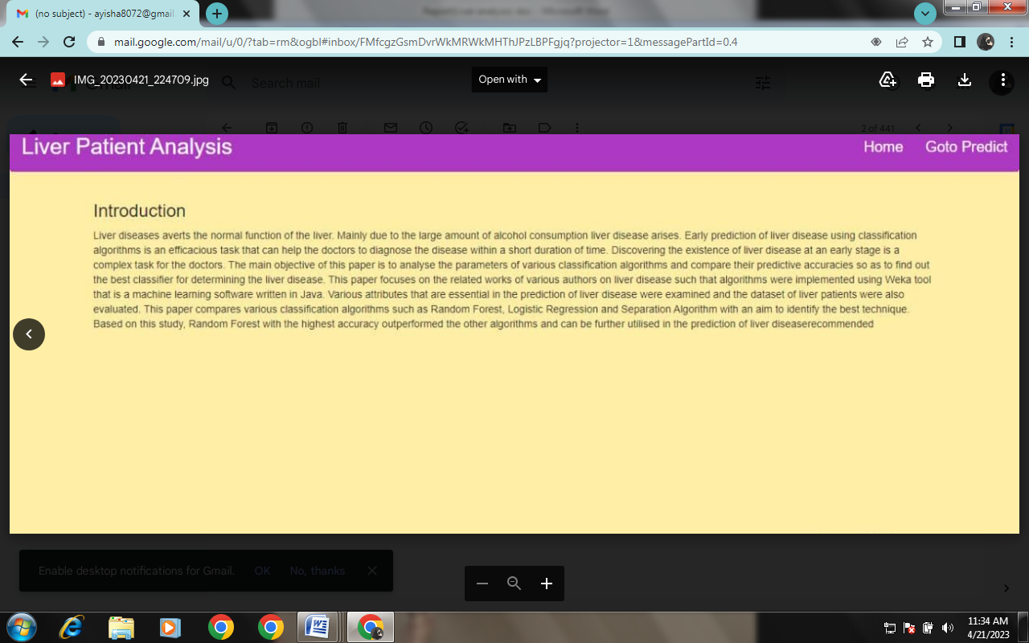

**Index.html**

|  |
| --- |
| <!DOCTYPE html> |
|  | <html> |
|  | <head> |
|  | <title>Liver Patient Analysis</title> |
|  | <!-- Latest compiled and minified CSS --> |
|  | <link rel="stylesheet" href="https://maxcdn.bootstrapcdn.com/bootstrap/3.3.7/css/bootstrap.min.css"> |
|  |  |
|  | <style type="text/css"> |
|  | body{ |
|  | background-color: #ffcf0059; |
|  | } |
|  | .page-header{ |
|  | background-color: blue; |
|  | width: 100%; |
|  | height: auto; |
|  | text-align: center; |
|  | padding-top: 5px; |
|  | color: #fff; |
|  | } |
|  | h1{ |
|  | font-size: 40px; |
|  | font-weight: bold; |
|  | } |
|  | </style> |
|  | </head> |
|  | <body> |
|  |  |
|  | <div class="container"> |
|  | <div class="row"> |
|  | <div class="col-md-3"></div> |
|  | <div class="col-md-6"> |
|  | <div class="page-header"> |
|  | <h1>Liver Patient Prediction</h1> |
|  | </div> |
|  | </div> |
|  | </div> |
|  | </div> |
|  |  |
|  | <div class="container"> |
|  | <div class="row"> |
|  | <div class="col-md-3"></div> |
|  | <div class="col-md-6"> |
|  | <form action="/data_predict" method="POST"> |
|  | <div class="row"> |
|  | <div class="col-md-6"> |
|  | <div class="form-group"> |
|  | <label for="age">Age:</label> |
|  | <input type="text" class="form-control" id="age" name="age"> |
|  | </div> |
|  | </div> |
|  |  |
|  | <div class="col-md-6"> |
|  | <div class="form-group"> |
|  | <label for="gender">Gender:</label> |
|  | <input type="text" class="form-control" id="gender" name="gender" placeholder="Enter 0 as male, 1 as female"> |
|  | </div> |
|  | </div> |
|  | </div> |
|  |  |
|  | <div class="row"> |
|  | <div class="col-md-6"> |
|  | <div class="form-group"> |
|  | <label for="tb">Total_Bilirubin:</label> |
|  | <input type="text" class="form-control" id="tb" name="tb"> |
|  | </div> |
|  | </div> |
|  | <div class="col-md-6"> |
|  | <div class="form-group"> |
|  | <label for="db">Direct_Bilirubin:</label> |
|  | <input type="text" class="form-control" id="db" name="db"> |
|  | </div> |
|  | </div> |
|  | </div> |
|  |  |
|  |  |
|  | <div class="row"> |
|  | <div class="col-md-6"> |
|  | <div class="form-group"> |
|  | <label for="ap">Alkaline_Phosphotase:</label> |
|  | <input type="text" class="form-control" id="ap" name="ap"> |
|  | </div> |
|  | </div> |
|  |  |
|  | <div class="col-md-6"> |
|  | <div class="form-group"> |
|  | <label for="aa1">Alamine_Aminotransferase:</label> |
|  | <input type="text" class="form-control" id="aa1" name="aa1"> |
|  | </div> |
|  | </div> |
|  | </div> |
|  |  |
|  | <div class="row"> |
|  | <div class="col-md-6"> |
|  | <div class="form-group"> |
|  | <label for="aa2">Aspartate_Aminotransferase:</label> |
|  | <input type="text" class="form-control" id="aa2" name="aa2"> |
|  | </div> |
|  | </div> |
|  | <div class="col-md-6"> |
|  | <div class="form-group"> |
|  | <label for="tp">Total_Protiens:</label> |
|  | <input type="text" class="form-control" id="tp" name="tp"> |
|  | </div> |
|  | </div> |
|  | </div> |
|  |  |
|  |  |
|  |  |
|  | <div class="row"> |
|  | <div class="col-md-6"> |
|  | <div class="form-group"> |
|  | <label for="a">Albumin:</label> |
|  | <input type="text" class="form-control" id="a" name="a"> |
|  | </div> |
|  | </div> |
|  | <div class="col-md-6"> |
|  | <div class="form-group"> |
|  | <label for="agr">Albumin_and_Globulin_Ratio:</label> |
|  | <input type="text" class="form-control" id="agr" name="agr"> |
|  | </div> |
|  | </div> |
|  | </div> |
|  |  |
|  |  |
|  |  |
|  | <button type="submit" class="btn btn-default">Predict</button> |
|  | </form> |
|  | </div> |
|  | </div> |
|  | </div> |
|  |  |
|  |  |
|  |  |
|  | <!-- Latest compiled and minified JavaScript --> |
|  | <script src="https://maxcdn.bootstrapcdn.com/bootstrap/3.3.7/js/bootstrap.min.js"></script |
|  | </body> |
|  | </html> |

Give feedback

**Output**

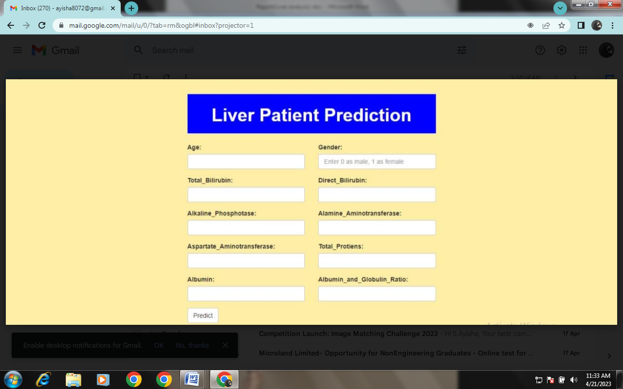

**Chance.html**

|  |
| --- |
| <!DOCTYPE html> |
|  | <html> |
|  | <head> |
|  | <title>Liver Patient Analysis</title> |
|  | <!-- Latest compiled and minified CSS --> |
|  | <link rel="stylesheet" href="https://maxcdn.bootstrapcdn.com/bootstrap/3.3.7/css/bootstrap.min.css"> |
|  |  |
|  | <style type="text/css"> |
|  | body{ |
|  | background-color: #ffcf0059; |
|  | } |
|  | .page-header{ |
|  | background-color: blue; |
|  | width: 100%; |
|  | height: auto; |
|  | text-align: center; |
|  | padding-top: 5px; |
|  | color: #fff; |
|  | } |
|  | h1{ |
|  | font-size: 40px; |
|  | font-weight: bold; |
|  | } |
|  | h3{ |
|  | font-size: 20px; |
|  | font-weight: bold; |
|  | } |
|  | </style> |
|  | </head> |
|  | <body> |
|  |  |
|  | <div class="container"> |
|  | <div class="row"> |
|  | <div class="col-md-3"></div> |
|  | <div class="col-md-6"> |
|  | <div class="page-header"> |
|  | <h1>Liver Patient Prediction</h1> |
|  | </div> |
|  | </div> |
|  | </div> |
|  | </div> |
|  |  |
|  |  |
|  |  |
|  | <div class="container"> |
|  | <div class="row"> |
|  | <div class="col-md-3"></div> |
|  | <div class="col-md-6"> |
|  | <div class="p-2 my-2 border"> |
|  | <h3>{{prediction}}</h3> |
|  | </div> |
|  | </div> |
|  | </div> |
|  | </div> |
|  |  |
|  |  |
|  | <!-- Latest compiled and minified JavaScript --> |
|  | <script src="https://maxcdn.bootstrapcdn.com/bootstrap/3.3.7/js/bootstrap.min.js"></script |
|  | </body> |
|  | </html> |

**Output**

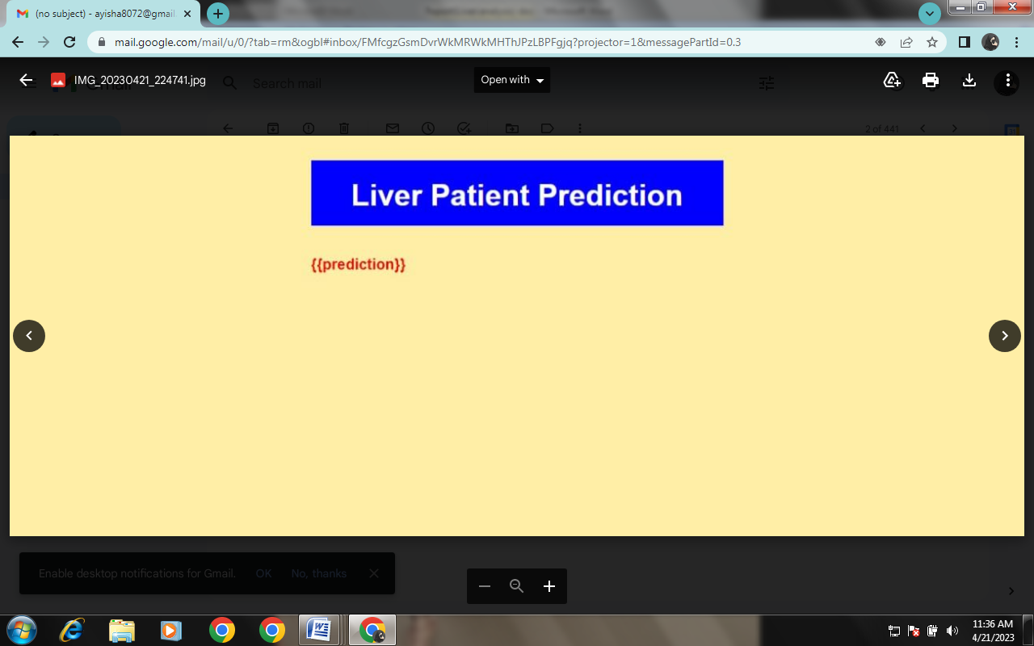

NOchance.html

|  |
| --- |
| <!DOCTYPE html> |
|  | <html> |
|  | <head> |
|  | <title>Liver Patient Analysis</title> |
|  | <!-- Latest compiled and minified CSS --> |
|  | <link rel="stylesheet" href="https://maxcdn.bootstrapcdn.com/bootstrap/3.3.7/css/bootstrap.min.css"> |
|  |  |
|  | <style type="text/css"> |
|  | body{ |
|  | background-color: #ffcf0059; |
|  | } |
|  | .page-header{ |
|  | background-color: blue; |
|  | width: 100%; |
|  | height: auto; |
|  | text-align: center; |
|  | padding-top: 5px; |
|  | color: #fff; |
|  | } |
|  | h1{ |
|  | font-size: 40px; |
|  | font-weight: bold; |
|  | } |
|  | h3{ |
|  | color: red; |
|  | font-size: 20px; |
|  | font-weight: bold; |
|  | } |
|  | </style> |
|  | </head> |
|  | <body> |
|  |  |
|  | <div class="container"> |
|  | <div class="row"> |
|  | <div class="col-md-3"></div> |
|  | <div class="col-md-6"> |
|  | <div class="page-header"> |
|  | <h1>Liver Patient Prediction</h1> |
|  | </div> |
|  | </div> |
|  | </div> |
|  | </div> |
|  |  |
|  |  |
|  | <div class="container"> |
|  | <div class="row"> |
|  | <div class="col-md-3"></div> |
|  | <div class="col-md-6"> |
|  | <div class="p-2 my-2 border"> |
|  | <h3>{{prediction}}</h3> |
|  | </div> |
|  |  |
|  |  |
|  | </div> |
|  |  |
|  |  |
|  | <!-- Latest compiled and minified JavaScript --> |
|  | </div> |
|  | </div> |
|  | </html> |

Output

